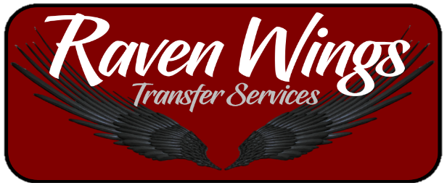

PRIVATE TRANFER PRICE LIST

PAX | TRANSFER COST
1 | R300
2 | R400
3 | R500

WE do bigger private groups please phone or email
the office for Quote on private groups

Please add R30 for Surfboards and Bicycles
Booking Hours are between 08:00 and 20:00
Booking Number: 076 632 1046
Email: bookings@ravenwings.co.za

